ERFWeb Signatory Guide
Oct 23, 2026 · @Jay Bryan

Before you start
As a signatory you approve the expense reports of the people your administrator assigned to you. Each report goes through its approvers in order: Level 1 first, then Level 2.
 | Level 1 | Level 2
Acts | First | After Level 1 approves
Can approve, return, reject | Yes | Yes
Can lower a line amount | Yes, before anyone approves | No
Can override a Level 1 who has not acted | No | Yes
Answers Finance queries | No | Yes
- Sign in to ERFWeb as usual; Approvals and Delegations appear in your left menu.
- You get an SMS and an email (with the R47 attached) when a report reaches you.
- You never act on your own report. Your own reports go to your own approvers.

Step 1: Find reports waiting for you
Everything routed to you is on the Approvals page.
- In the left menu, click Approvals.
- Pick a tab:
  - To review: reports where it is your turn, plus reports still waiting for an earlier approver.
  - Acted on: reports you already approved, returned or rejected.
  - Queries (Level 2 only): questions from Finance about a line that could not be verified.
- To find one report, type the employee's name, the purpose or the ERF reference number in the search box.
- Click a report to open it.
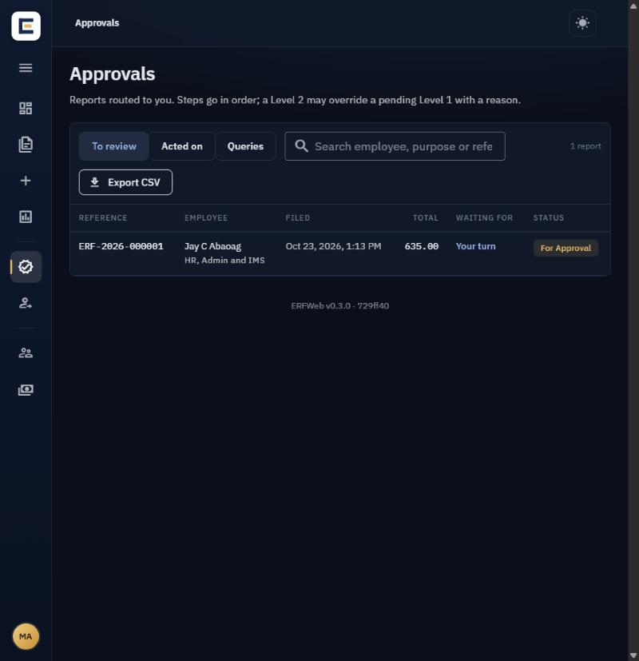

Step 2: Review the report
The review page shows the whole report as the employee filed it; check it before you decide.
- Read the header: report type, purpose, period and the totals (expenses, cash advance, balance due).
- Go through the Expense lines: date, particulars, the R47 column, VAT and amount. Lines are grouped by date and "Work with".
- Open the Receipts to check the scans match the lines.
- Check the approval timeline to see who has already approved.
- Click R47 PDF to see the printed form.
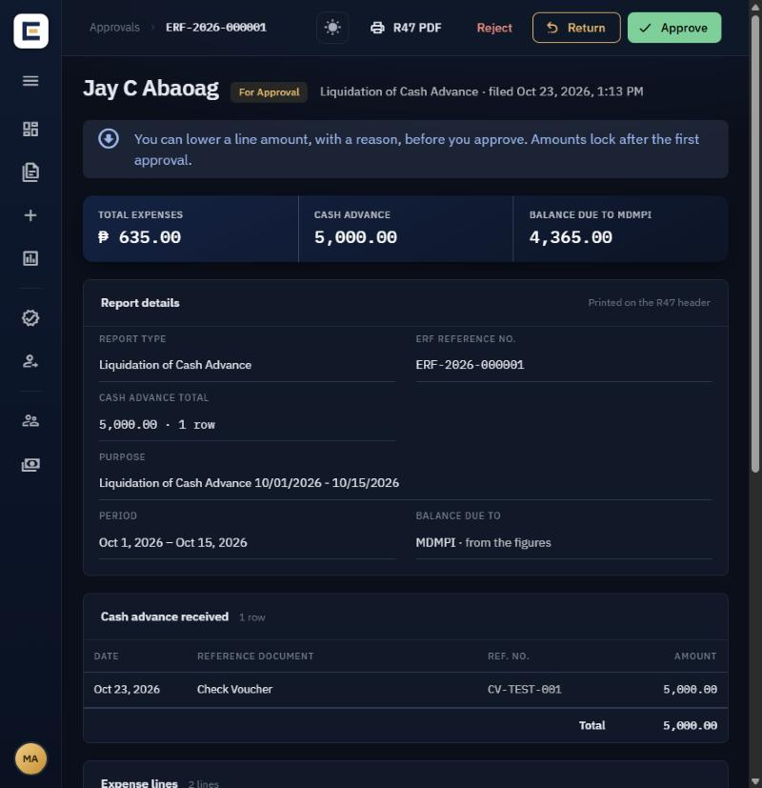
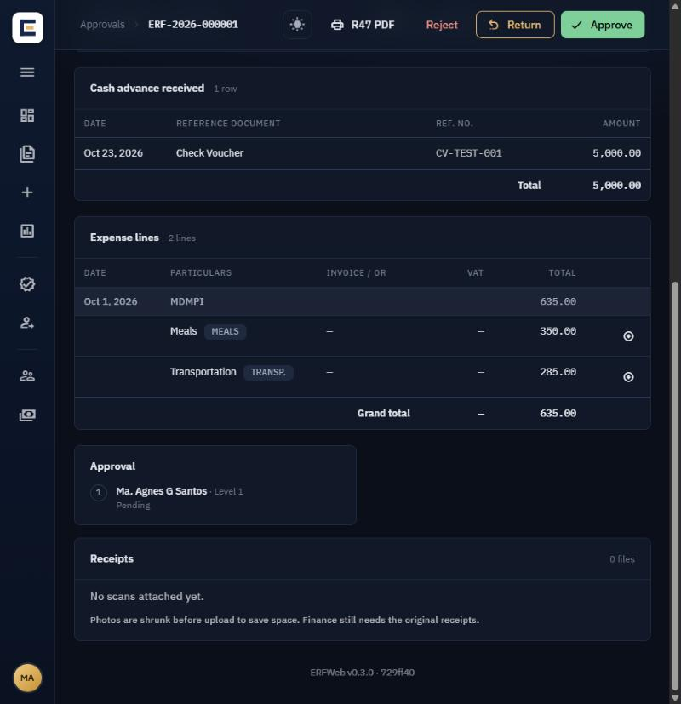

Step 3: Approve, return or reject
The buttons at the top of the review page show only the actions open to you right now; if none show, it is not your turn yet.
Button | When to use it | What happens | Note
Approve | The report is correct | Goes to the next approver; the last approval sends it to Finance | Optional
Return | The employee can fix it | Goes back to the employee; approval restarts from the first approver when they re-file | Required: what to fix
Reject | It should not be paid at all | Final; it can never be re-filed | Required: the reason
- Click the button.
- Read the confirmation and type your note.
- Click Approve, Return or Reject in the window to confirm.
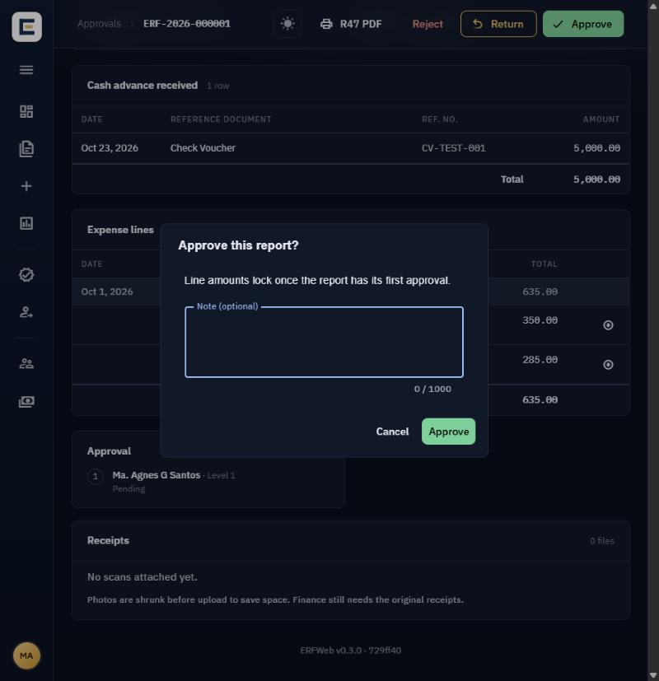
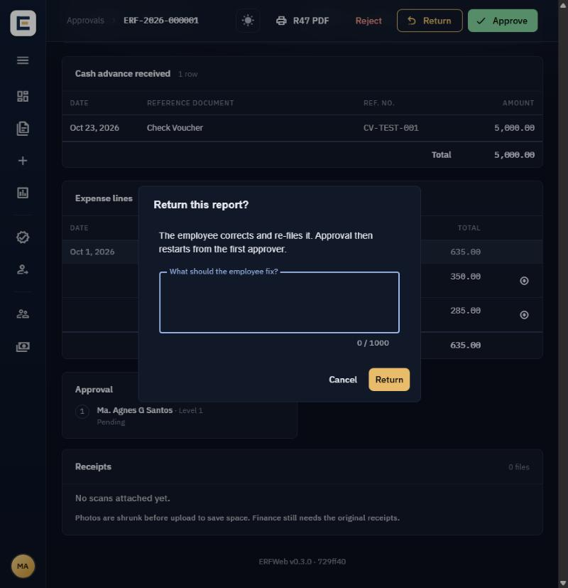
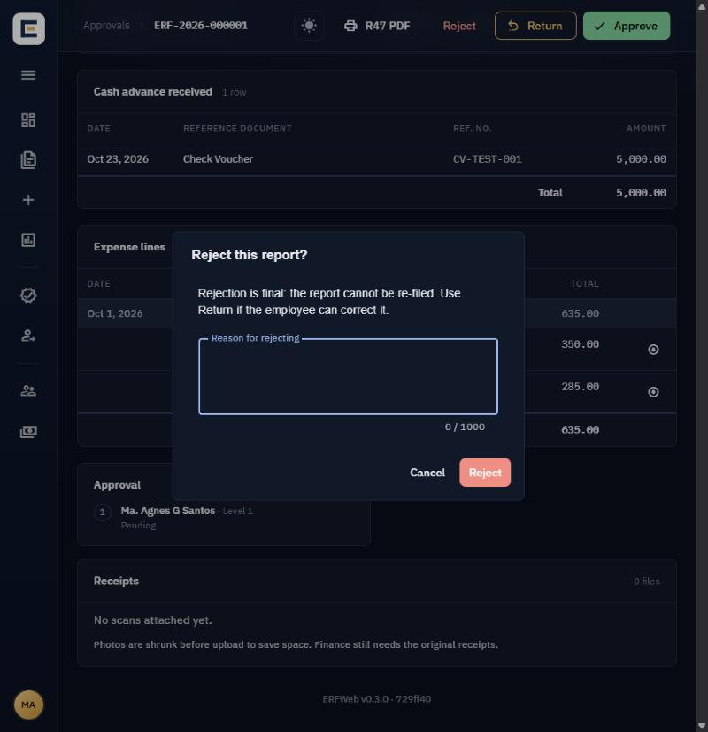
The employee and the other approvers get an SMS and an email; your note is quoted in them. Line amounts lock once the report has its first approval. Use Return, not Reject, whenever the employee can correct the report.

Level 1 only: Lower a line amount
If one expense is too high, a Level 1 can lower it instead of returning the whole report, but only before anyone approves.
- In the Expense lines, click the Lower amount icon (a down arrow) on the line.
- In Lower this amount, enter the New amount; it must be lower than the filed amount.
- Enter the Reason; the employee sees it.
- Click Lower amount, then approve the report as usual.
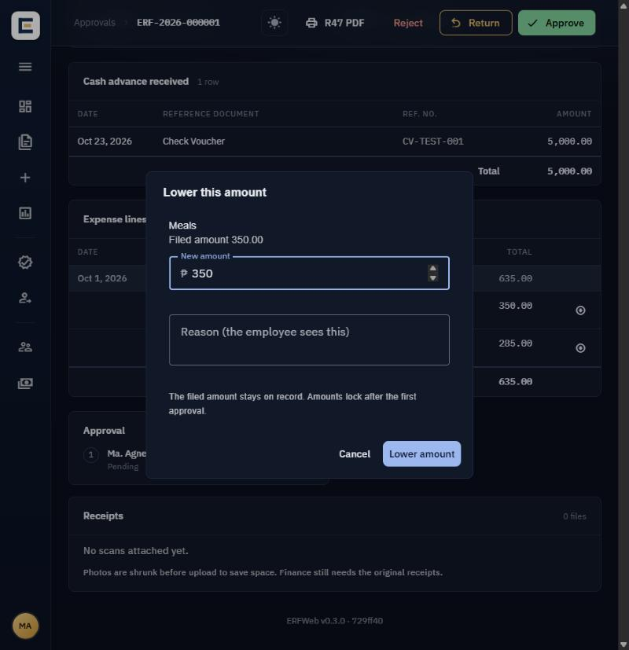
The filed amount stays on record and everyone sees both figures. You cannot raise an amount; return the report instead.

Level 2 only: Override and Finance queries
A Level 2 can move a stuck report past an absent Level 1, and decides on lines Finance could not verify.
Override a pending Level 1
- Open the report from To review while it still waits for its Level 1.
- Click Override.
- In Approve without the Level 1?, explain why, then click Override and approve.
The Level 1 step is marked Overridden and the report is approved; your reason is kept in the audit trail. If the Level 1 is only away for a while, a delegation (next section) is usually better.
Answer a Finance query
- Open the Queries tab in Approvals and click the report.
- Read the line in question and the verifier's finding in the Verification card.
- Choose one:
  - Let it through: Finance carries on and can clear the report.
  - Return for correction: the employee corrects and re-files; approval restarts. A note is required.
  - Reject the report: final; it cannot be re-filed. A note is required.
- Confirm. Answered queries move to Decided.

Going on leave: Set up a delegation
Name a delegate before you leave so reports don't wait for you; only approving is delegated, never rates or scope.
- In the left menu, click Delegations, then New delegation.
- If the window shows Whose approvals, choose Mine. That choice appears only for a Level 2 who is over Level 1s: pick A Level 1 I am over when one of them is away and left no delegate, then pick the Level 1 signatory.
- Pick the Delegate: a signatory of your level or higher.
- Set From and To (at most 90 days) and an optional Reason, e.g. On leave.
- Click Save.
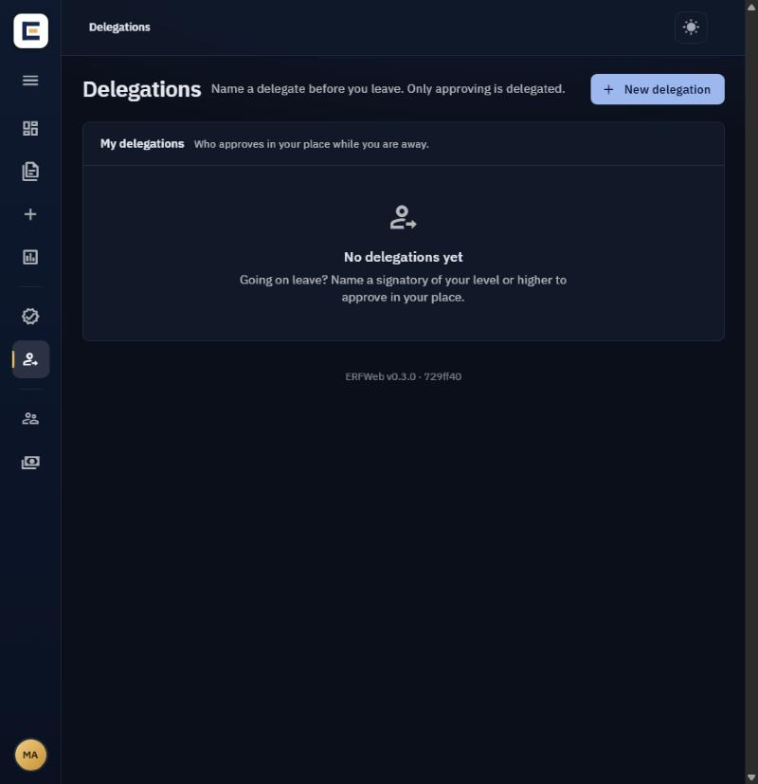
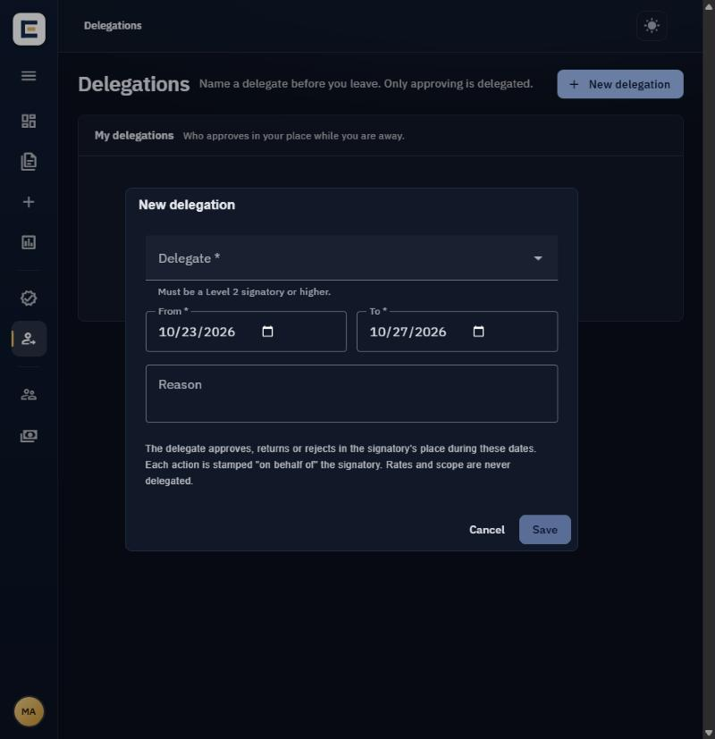
During those dates the delegate approves, returns or rejects for you, and each step reads "on behalf of" you. The R47 prints the delegate's own signature. To end it early, click Cancel on the delegation, then Cancel delegation.

Exports and common problems
Export CSV on the Approvals page downloads the current tab and search as a spreadsheet. Summary in the left menu totals the expenses of the reports you approve, as CSV or PDF.
What you see | What to do
A report is in To review but has no Approve button | It is waiting for an earlier approver
The page reloads after you click a button | Someone acted at the same moment; check the timeline and act again if it is still your turn
The Lower amount icon is missing | Only the Level 1 sees it, and only before the first approval
An employee asks you to change an approved report | Ask them to have it returned; approved amounts are locked
You want to approve but you are the employee on it | You can't; your own reports go to your own approvers
A report from someone outside your team appears, or one is missing | Ask your administrator to check your scope

